**Level: Easy  
  
Q1:**

If a doctor gives you 3 pills and tells you to take one pill every half hour, how long would it be before all the pills had been taken?

Answer:

1 hour.   
If you take a pill at 1 o'clock, then another at 1.30 and the last at 2'clock, they will be taken in 1 hour

**Q2:**

I went to bed at eight 8 clock in the evening and wound up my clock and set the alarm to sound at nine 9 clock in the morning. How many hours sleep would I get before being awoken by the alarm?

Answer:

1 hour. It is a wind up alarm clock which cannot discriminate between a.m. and p.m.  
  
**Q3:**

Mary, who is sixteen years old, is four times as old as her brother. How old will Mary be when she is twice as old as her brother?  
20

24

25

26

28

Answer:

24

**Q4:**

Which number should replace the question mark?

8 5 21

35 32 12

32 28 31

4 ? 28

A. 3

B. -2

C. -6

D. 48

**Answer:**

C  
  
**Q6:**  
In the above problem,

E is lighter in weight than which of the following pairs?

☛ B,D

☛ D,C

☛ A,D

☛ B,C

☛ A,B  
  
Answer:

► A,B

Explanation: On logical interpretation of the given statements one can arrive at the following conclusion:

A>B>E>D>C in order of decreasing weight. Hence, it can be seen that E is the lighter than A and B.  
  
**Q7:**

If A is the son of Q, Q and Y are sisters, Z is the mother of Y, P is the son of Z, then which of the following statements is correct ?

A. P is the maternal uncle of A

B. P and Y are sisters

C. A and P are cousins

D. None of the above  
  
Answer:  
A.

**Q8:**

Which one of the numbers does not belong in the following series?

► 2

► 3

► 6

► 7

► 8

► 14

► 15

► 30  
  
Answer:

► 8

**Q9:**

Which one of the numbers does not belong in the following series?

► 1

► 2

► 5

► 10

► 13

► 26

► 29

► 48  
  
Answer:

► 48  
  
**Q10:**

What is the missing number in the sequence shown below?

► 1

► 8

► 27

► ?

► 125

► 216  
  
Answer:

► 64

**Level: Medium**

**Q11:**What number should replace the question mark?  
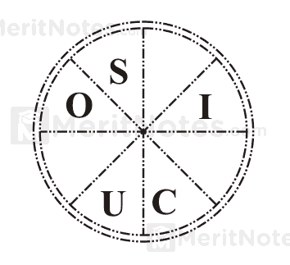



**Answer: 132  
  
Q12:**

What number should replace the question mark?  
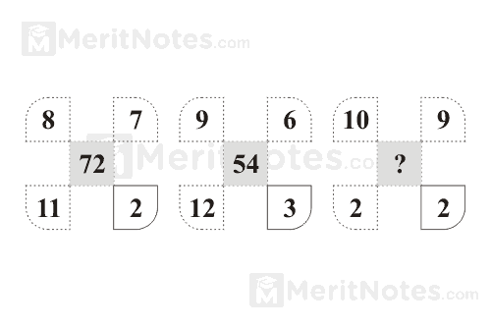

**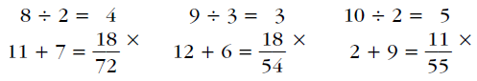  
Answer: 55  
  
Q13:**What number should replace the question mark?  
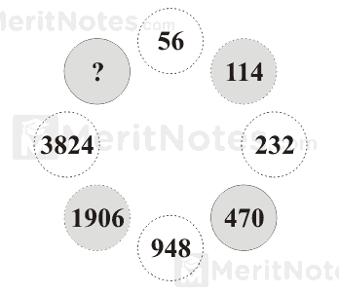

  
  
Answer: 7662  
  
**Q14:**

What number should replace the question mark?  
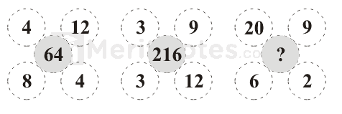

Solution:

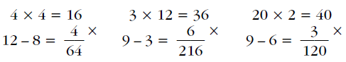  
Answer: 120  
  
**Q15:**

What number should replace the question mark to provide the missing link?

Solution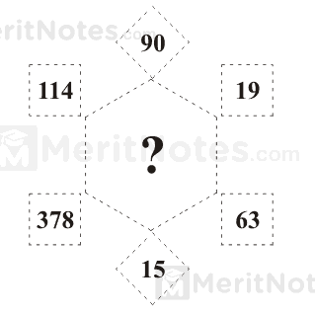

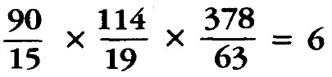  
Answer: 6  
  
**Q16:**

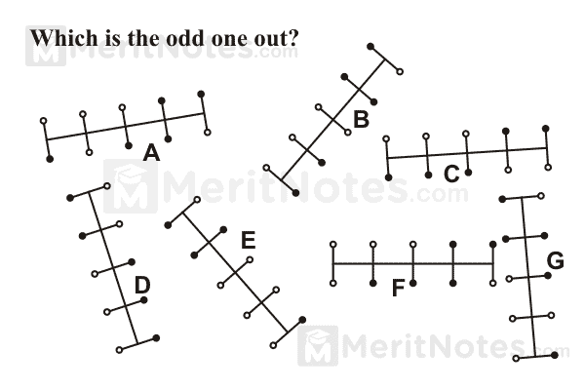

Answer: F

A and G are the same, as are B and E, and C and D.  
  
**Q17:**

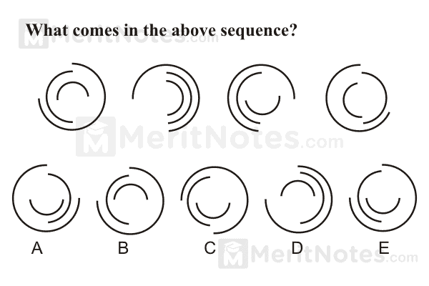  
Answer: B

The outer segment moves 90° anti clockwise at each stage, the middle segment moves 180° and the inner segment moves 90° clockwise.  
  
**Q18:**

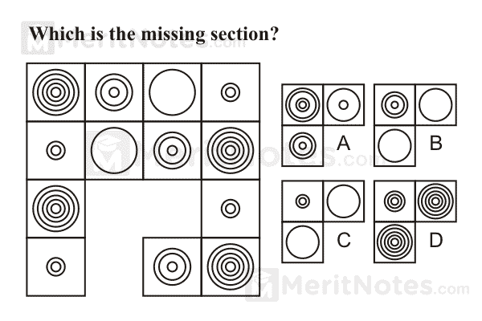

Answer: B

Start at the top left hand corner and work along the top row and back along the second row, etc. repeating the four different arrangements of circles. Thus the bottom row is the reverse of the top row, and the third row is the reverse of the second row.  
  
**Q19:**

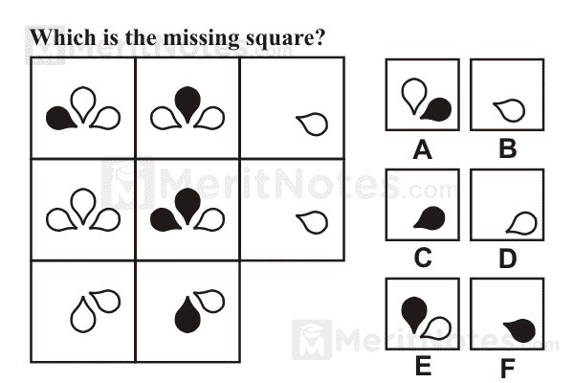

Answer: D

Looking across the line, the contents of the third square are determined by the contents of the first two. Only when a symbol appears the same color in the first two squares is it carried forward to the third square; however, it then appears upside down.  
  
**Q20:**

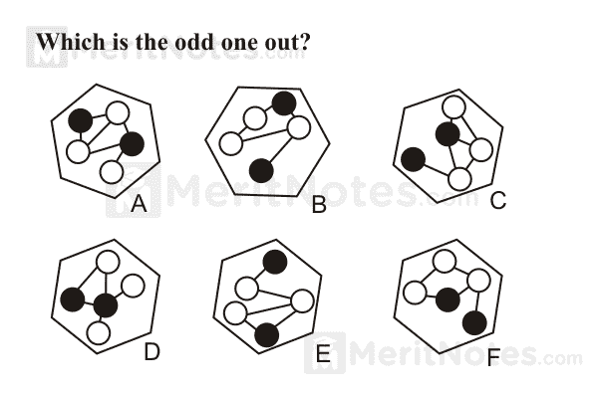

Answer: D

The only one where two black dots are directly connected.  
  
**Q21:**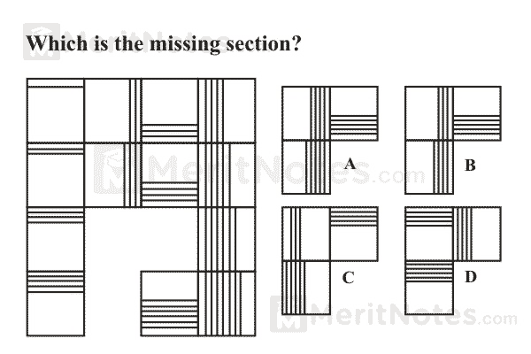  
  
Ans: A

Looking down, the number of lines increases by 1 each time. Looking across, the number of lines also increases by 1, but the lines alternate horizontally and vertically.  
  
**Q22:**

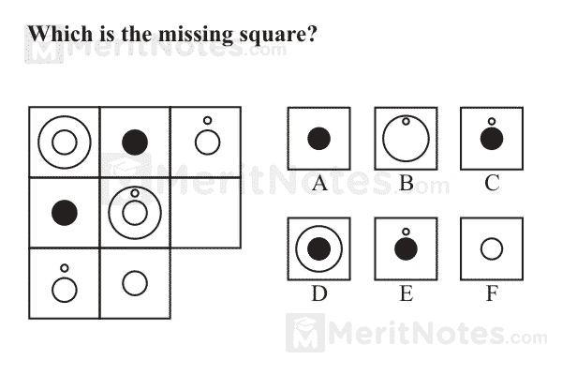

Ans: D

There is one each of the four different symbols in each horizontal and vertical line. i.e. one large white circle, two medium size white circles (one with a small white circle above it) and one black circle.

**Q23:**

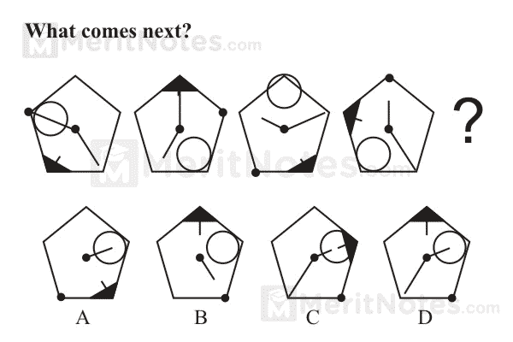Ans: C

The arrow moves two corners clockwise, the large circle three corners clockwise, the black dot three corners anti clockwise, the longer line one corner clockwise and the shorter line one corner clockwise.  
  
**Q24:**

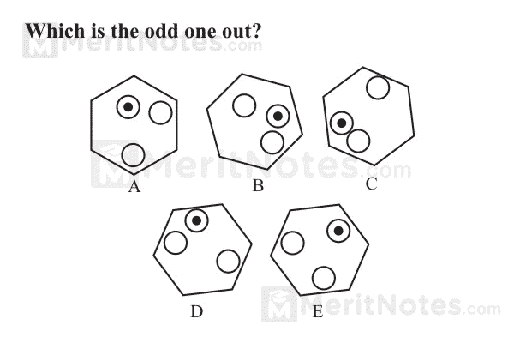

Ans: B

A is the same as E, and C is the same as D.  
  
**Q25:  
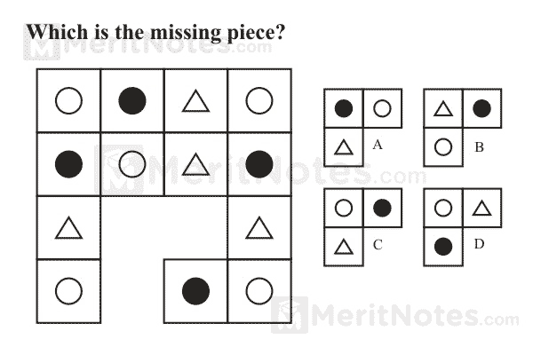**Ans: C

Start at the top left hand square and work along the top and then back along the second row etc. in the sequence white circle, black circle, triangle.  
  
**Q26:**

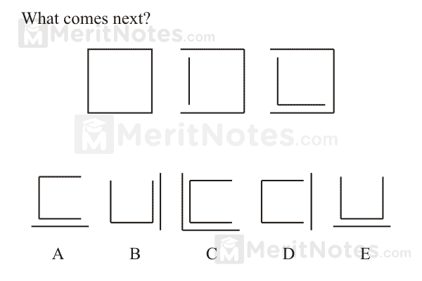  
Ans: E

The large square is disappearing a side at each stage working clockwise and the small square is being constructed a side at a time working anti clockwise.  
  
**Q27:  
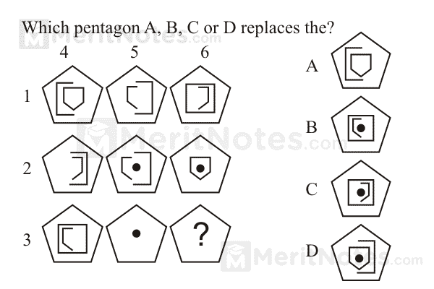**Ans: B

1 is added to 2 to equal 3

4 is added to 5 to cancel 6 like symbols disappear  
  
**Q28:**

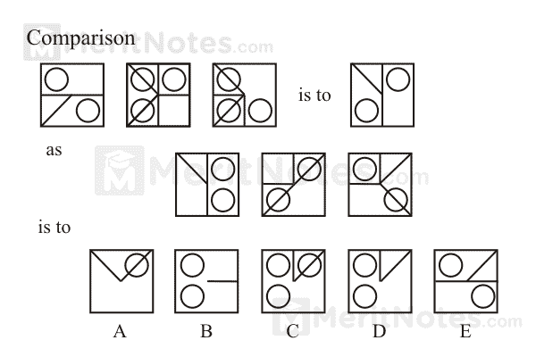  
Ans: D

Only lines which appear in the same position just twice in the first three squares are transferred to the final square. Only circles which appear in the same position just once are transferred.  
  
**Q29:**

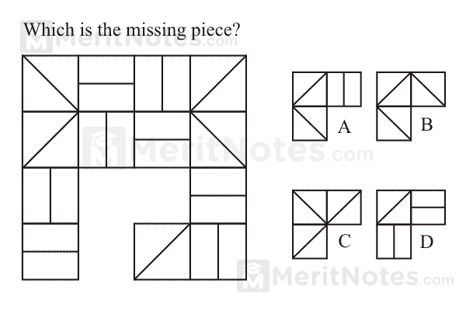

Ans: B

So that each horizontal and vertical line contains one each of the four different lines.  
  
**Q30:**

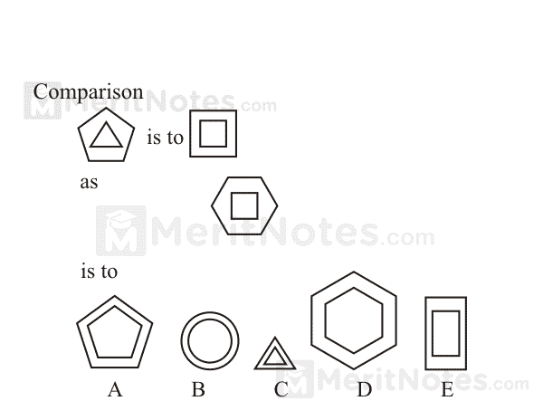Ans: A

The number of sides on the outside figure decreases by one, but the number of sides on the inside figure increases by one.  
  
**Level: Difficult**

**Q31.**

What number should replace the question mark?  
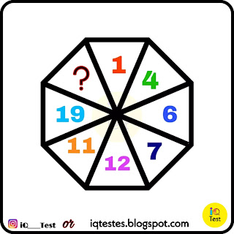  
  
(A) 13

(B) 16

(C) 18

(D) 21  
  
Answer: B

**Q32:**

Which Number Can be placed in place of Question Mark?

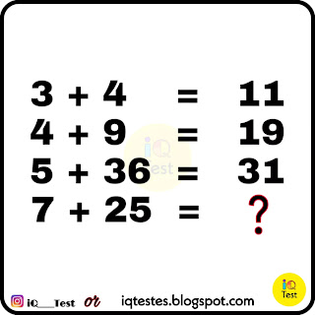

(A) 32

(B) 37

(C) 39

(D) 54  
  
Answer: D  
  
**Q33:**

What is the Correct Answer?

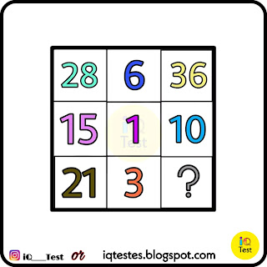

(A) 22

(B) 23

(C) 44

(D) 46

Answer: D  
  
**Q34:**

Can You say what is the right Answer?  
  
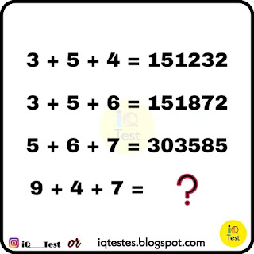

(A) 366339

(B) 366329

(C) 366335

(D) 366391  
  
Answer: B

**Q35:**

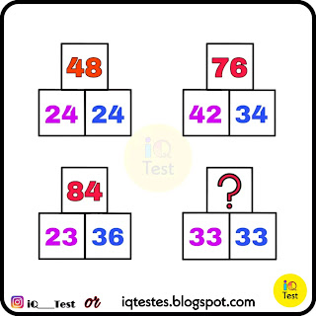

(A) 66

(B) 65

(C) 64

(D) 63  
  
**Solution:**

24 + 24

if , (2×4) (2×4) = (8) (8)

then ,

8 × 8 = 64 - (8 + 8 ) = 48

42 + 34

if, (4×2) (3×4) = (8) (12)

then,

8 × 12 = 96 - (8 + 12) = 76

23 + 36

if , (2 × 3) (3 × 6) = (6) (18)

then,

6 × 18 = 108 - (6 + 18 ) = 84

33 + 33

if , (3×3) (3×3) = (9) (9)

then ,

(9)×(9) = 81 - (9)+(9)

81- 18 = 63

**Q36:**

Which One Is Correct?

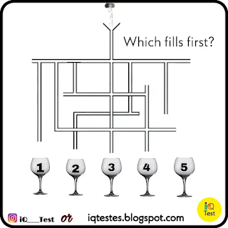

Answer: 4

**Q37:**

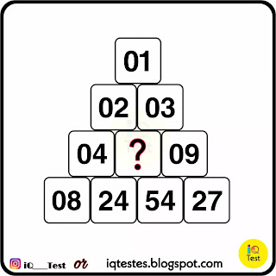(A) 05

(B) 06

(C) 18

(D) 26

**Solution:**

Left Side

1 * 2 = 2

2 * 2 = 4

4 * 2 = 8

Right Side

1 * 3 = 3

3 * 3 = 9

9 * 3 = 27

In Center

2 * 3 = 6

4 * 6 = 24

6 * 9 = 54

**Answer**: B

**Q38:**

How Many Triangles?

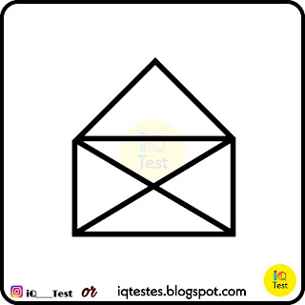

(A) 09

(B) 10

(C) 11

(D) 12

Answer: 9  
  
**Q39:**

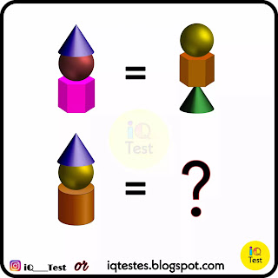Options

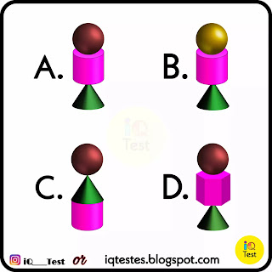

Answer: A

**Q40:**

What is the Correct Answer?  
  
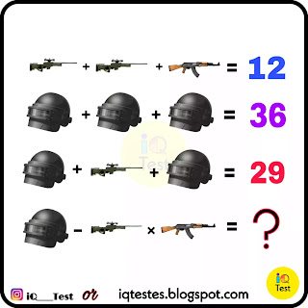

(A) 02

(B) 04

(C) 14

(D) 16

**Answer:** 02

**Solution:**  
Awm - 05 | AK47 - 02 | Helmet - 12

According to BODMAS.

= 12 - 5 * 2

= 12 - 10

= 02

**Q41:**

What is the correct Answer?

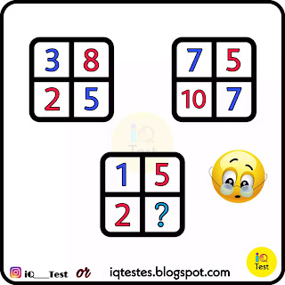  
  
(A) 05

(B) 14

(C) 09

(D) 10

Answer: C

Solution:

(8 × 2) - (3 × 5)

16 - 15

= 1

(10 × 5) - (7 × 7)

50 - 49

= 1

(5 × 2) - ( ? × 1) = 1

10 - (?) = 1

(?) = 10 - 1

(?) = 9 ✓

**Q42:**

How Many Triangles?

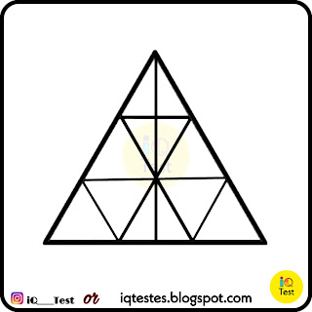

(A) 15

(B) 21

(C) 23

(D) 25

Answer: D

**Q43:**

How Many Triangles?

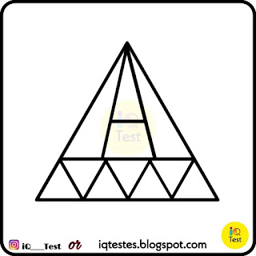

(A) 10

(B) 13

(C) 15

(D) 17

Answer: C

**Q44:**

What is the value of star?

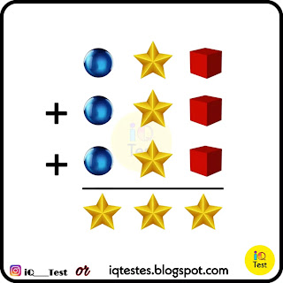

1 4 8

1 4 8

1 4 8

---------

4 4 4

So, The Value of Star 🌟 is 4.  
  
**Q45:**

What is the Correct Answer?

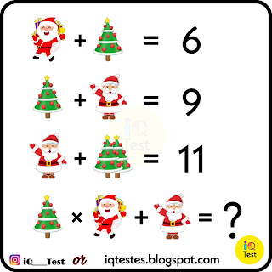

(A) 15

(B) 17

(C) 20

(D) 22

**Answer**: A

**Solution**:

1 Santa - 04 | Tree - 02 | 2 Santa - 07

According to BODMAS.

= 2 * 4 + 7

= 8 + 7

= 15

**Q46:**

What is the Correct Answer?  
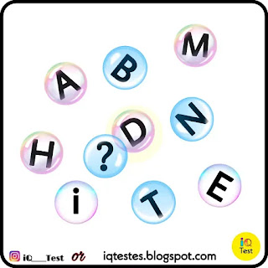

(A) C

(B) G

(C) K

(D) S

Answer: S

**Solution:**

Between B & D 1 Alphabet

Between E & H 2 Alphabet

Between I & M 3 Alphabet

Between N & S 4 Alphabet

So, Answer is S

**Q47:**

What is the Correct Answer?

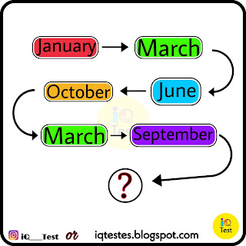

(A) July

(B) April

(C) February

(D) December

**Answer**: April  
**Solution**:

Feb (1 Month)

April, May (2 Month)

July, Aug, Sep (3 Month)

Nov, Dec, Jan, Feb (4 Month)

April, May, June, July, Aug (5 Month)

Oct, Nov, Dec, Jan, Feb, March (6 Month)

**Q48:**

What is the Right Answer?

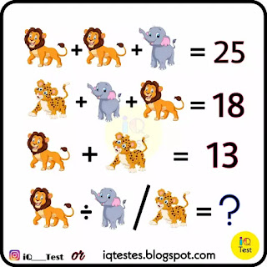

(A) 2/3

(B) 05

(C) 06

(D) 10

Answer: C

Lion - 10 | Elephant - 05 | Leopard - 03

According to BODMAS.

= 10 / (5/3)

= 30 / 5

= 06

**Q49:**

How Many Triangles?

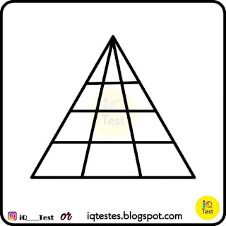

(A) 14

(B) 18

(C) 24

(D) 28

Answer: 24

**Q50:**

Which One Is Correct?

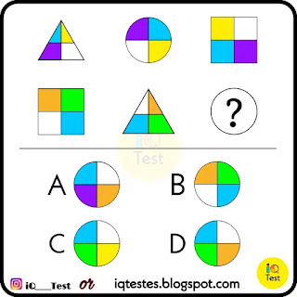

Answer: D

**Q51:**

Which is the Right Answer?

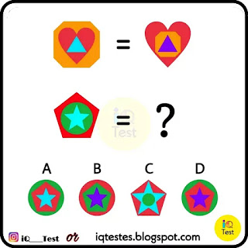

Answer: D

**Q52:**

What is the Correct Answer?

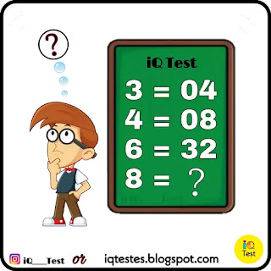

(A) 048

(B) 056

(C) 116

(D) 128

Answer: D

2^3 / 2 = 8 / 2 = 04

2^4 / 2 = 16 / 2 = 08

2^6 / 2 = 64 / 2 = 32

2^8 / 2 = 256 / 2 = 128

= 128.

**Q53:**

What is the Right Answer?

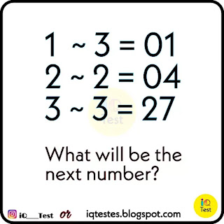

(A) 016

(B) 064

(C) 128

(D) 256

Answer is A

1 ~ 3 = 01 (1^3)

2 ~ 2 = 04 (2^2)

3 ~ 3 = 27 (3^3)

4 ~ 2 = 16 (4^2)

= 016

**Q54:**

How Many Triangles?

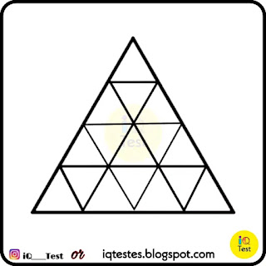

(A) 17

(B) 27

(C) 26

(D) 30

Answer: B

**Q55:**

What is the Right Answer?

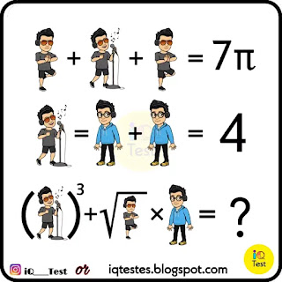

(A) 020

(B) 030

(C) 070

(D) 134

Answer: C

**Q56:**

What is the Right Answer?

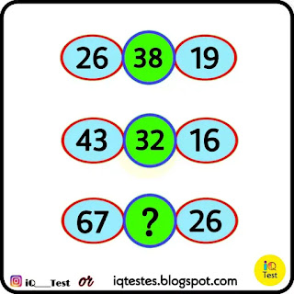

(A) 30

(B) 52

(C) 54

(D) 60

Answer: B

= 67 + 26 - (67 - 26)

= 93 - 41

= 52

**Q57:**

What is the Right Answer?

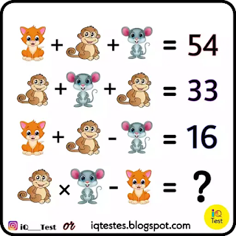

(A) 102

(B) 105

(C) 110

(D) 115

Answer: B

Cat - 10 | Mouse - 19 | Monkey - 07

According to BODMAS.

= 7 * 19 - 28

= 133 - 28

= 105

**Q58:**

What is the Correct Answer?

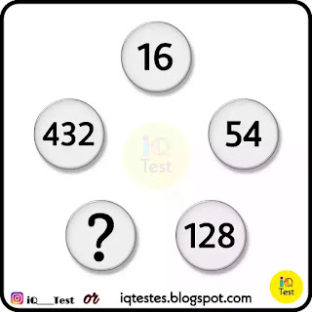

(A) 250

(B) 256

(C) 260

(D) 270

Answer: A

2^3 * 2 = 16

3^3 * 2 = 54

4^3 * 2 = 128

5^3 * 2 = 250

**Q59:**Fill in the blank

? T T F F

S S E N T

E T T F F

S S E N T

Answer: O

The letters are the first alphabets with which the counting numbers start. One, Two, Three etc.

**Q60:**Complete the sequence:

B E J Q ?

Answer: Z

Explanation:

B+3=E

E+5=J

J+7=Q

Q+9=Z

**Q61:**

If 0=4, 1=3, 2=3, 3=5, 4=4, 5=4, 6=3, 7=5, 8=5 and 9=4, find the value of 10, 11 and 12

Answer:

10=3, 11=6, 12=6.

Explanation: Number of letters in the spelling of each figure.

**Level: Easy**

**Q62:**Identify the figure that completes the pattern.

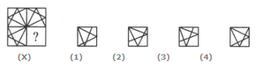

A. 1

B. 2

C. 3

D. 4

Answer: D

**Q63:**

Identify the figure that completes the pattern.

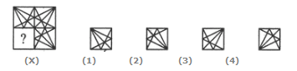

A. 1

B. 2

C. 3

D. 4

Answer: D

**Q64:**

Identify the figure that completes the pattern.

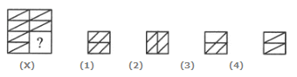

A. 1

B. 2

C. 3

D. 4

Answer: D

**Q65:**

Identify the figure that completes the pattern.

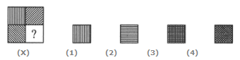

A. 1

B. 2

C. 3

D. 4

Answer: B

**Q66:**

Identify the figure that completes the pattern.

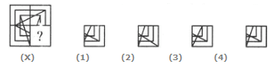

A. 1

B. 2

C. 3

D. 4

Answer: D

**Q67:**

Identify the figure that completes the pattern.

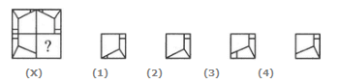

A. 1

B. 2

C. 3

D. 4

Answer: D

**Q68:**

Identify the figure that completes the pattern.

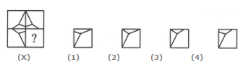

A. 1

B. 2

C. 3

D. 4

Answer: D

**Q69:**

Identify the figure that completes the pattern.

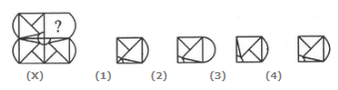

A. 1

B. 2

C. 3

D. 4

Answer: D

**Q70:**

Identify the figure that completes the pattern.

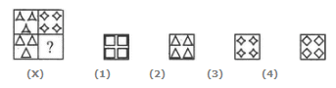

A. 1

B. 2

C. 3

D. 4

Answer: D

**Q71:**

Identify the figure that completes the pattern.

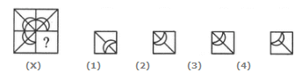

A. 1

B. 2

C. 3

D. 4

Answer: C

**Q72:**

Identify the figure that completes the pattern.

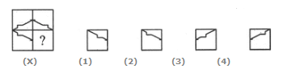

A. 1

B. 2

C. 3

D. 4

Answer: D

**Q73:**

Identify the figure that completes the pattern.

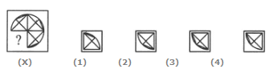

A. 1

B. 2

C. 3

D. 4

Answer: D

**Q74:**

Identify the figure that completes the pattern.

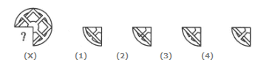

A. 1

B. 2

C. 3

D. 4

Answer: D

**Q75:**

Identify the figure that completes the pattern.

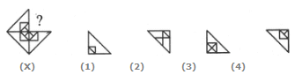

A. 1

B. 2

C. 3

D. 4

Answer: D

**Level: Difficult**

**Q76:**

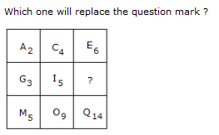

A. L10

B. K15

C. I15

D. K8

Answer: D

Explanation:

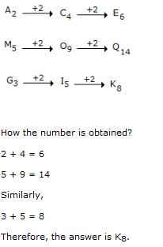

**Q77:**

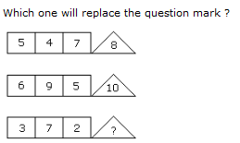

A. 1

B. 4

C. 3

D. 6

Answer: D

Explanation: (5 + 4 + 7)/2 = 8

(6 + 9 + 5)/2 = 10

(3 + 7 + 2)/2 = 6.

**Q78:**

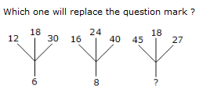

A. 18

B. 12

C. 9

D. 6

Answer: C

Explanation: (12 + 18 + 30)/10 = 6

(16 + 24 + 40)/10 = 8

Similarly, (45 + 18 + 27)/10 = 9.

**Q79:**

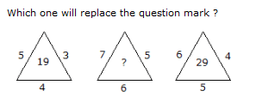

A. 25

B. 37

C. 41

D. 47

Answer: C

Explanation: (5 x 3) + 4 = 19

and (6 x 4) + 5 = 29

Therefore, (7 x 5) + 6 = 41

**Q80:**

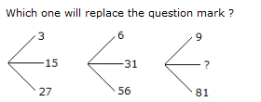

A. 45

B. 41

C. 32

D. 40

Answer: A

Explanation: (15 x 2 - 3) = 27,

(31 x 2 - 6) = 56

and (45 x 2 - 9) = 81

**Q81:**

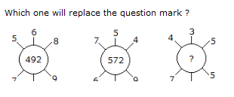

A. 115

B. 130

C. 135

D. 140

Answer: B

Explanation: (5 x 6 x 8) + (7 x 4 x 9) = 492

and (7 x 5 x 4) + (6 x 8 x 9) = 572

Therefore (4 x 3 x 5) + (7 x 2 x 5) = 130.

**Q82:**

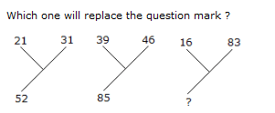

A. 92

B. 72

C. 62

D. 99

Answer: D

Explanation: 21 + 31 = 52

and 33 + 46 = 85

Therefore, 16 + 83 = 99.

**Q83:**

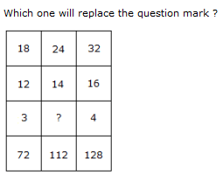

A. 2

B. 3

C. 4

D. 5

Answer: B

Explanation: (18 x 12)/3 = 72

and (32 x 16)/4 = 128

Therefore, (24 x 14)/? = 112

(336/?) = 112

? = (336/112)

? = 3.

**Q84:**

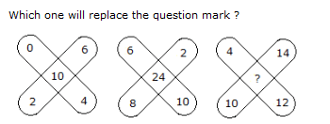

A. 36

B. 48

C. 38

D. 30

Answer: C

Explanation: (0 + 2 + 6 + 4) - 2 = 10

and (6 + 2 + 10 + 8) - 2 = 24

Therefore, (4 + 14 + 12 + 10) - 2 = 38.

**Q85:**

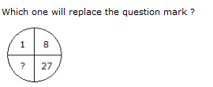

A. 41

B. 64

C. 35

D. 61

Answer: B

Explanation:



**Q86:**

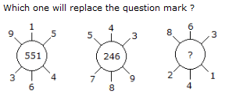

A. 262

B. 622

C. 631

D. 824

Answer: B

Explanation: 915 - 364 = 551

and 789 - 543 = 246

Similarly, 863 - 241 = 622.

**Q87:**

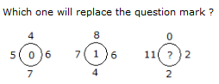

A. 0

B. 2

C. 11

D. 12

Answer: C

Explanation: (6 + 5) - (7 + 4) = 0

and (7 + 6) - (8 + 4) = 1

Therefore (11 + 2) - (2 + 0) = 11.

**Q88:**

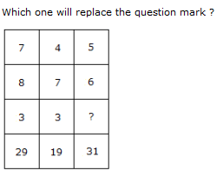

A. 3

B. 5

C. 4

D. 6

Answer: B

Explanation: (7 x 3) + 8 = 29

(4 x 3) + 7 = 19

(5 x ?) + 6 = 31

? = 5.

**Q89:**

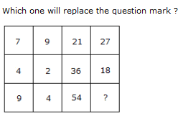

A. 18

B. 24

C. 36

D. 58

Answer: B

Explanation: (7 x 3) = 21 and (9 x 3) = 27

and (4 x 9) = 36 and (2 x 9) = 18

Therefore (9 x 6) = 54 and (4 x 6) = 24.

**Q90:**

Which one will replace the question mark ?

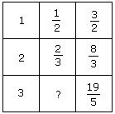

A. 1/2

B. 2/3

C. 3/4

D. ⅘

Answer: D

Explanation:

From I row, 1 + (1/2) = 3/2

From II row, 2 + (2/3) = 8/3

From III row, 3 + ? = 19/5

? = (19/5) - 3

? = (4/5).

**Q91:**

Which one will replace the question mark ?

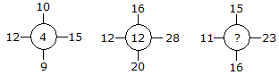

A. 11

B. 14

C. 10

D. 12

Answer: A

Explanation:

(15 - 12) + (10 - 9) = 4

(28 - 12) + (16 - 20) = 12

Similarly, (23 -11) + (15- 16) = 11.

**Q92:**

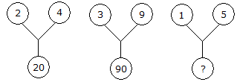

A. 75

B. 26

C. 25

D. 20

Answer: B

Explanation:

(2)2 + (4)2 = 20

and (3)2 + (9)2 = 90

Therefore (1)2 + (5)2 = 26.

**Q93:**

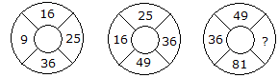

A. 64

B. 144

C. 169

D. 25

Answer: Option A

Explanation:

The numbers are squared in ascending order

In first circle,

(3)2 = 9

(4)2 = 16

(5)2 = 25

(6)2 = 36.

In second circle,

(4)2 = 16

(5)2 = 25

(6)2 = 36

(7)2 = 49.

In third circle,

(6)2 = 36

(7)2 = 49

(8)2 = 64

(9)2 = 81.

**Q94:**

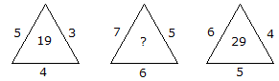

A. 25

B. 37

C. 41

D. 47

Answer: C

Explanation:

(5 x 3) + 4 = 19

and (6 x 4) + 5 = 29

Therefore, (7 x 5) + 6 = 41

**Q95:**

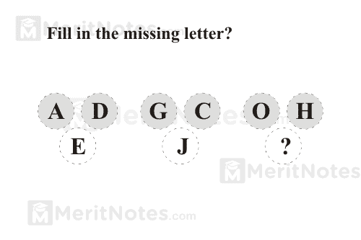

Answer: 55

Each number is the number above it times 3 plus either 2, 3 plus either 2, 3 or 4, depending on which column it is. 55 = 17 x 3 + 4. 169 = 55 x 3 + 4.

**Q96:**

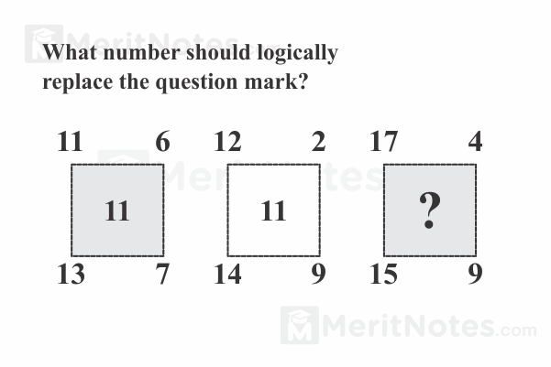

Ans: 15

The center number is the sum of the top left number, the top right number, and the lower right number, minus the lower left number.

17 + 4 + 9 â€“ 15 = 15.

**Q97:**

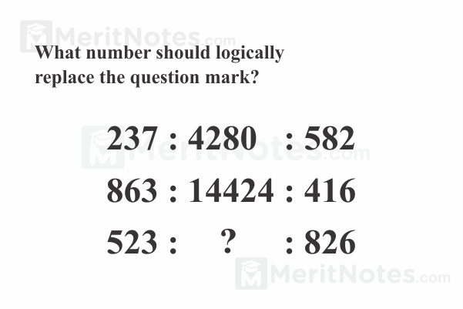

Answer: 3096.

The center number in each row is the product of the digits on the left followed by the product of the digits on the right.

**Q98:**

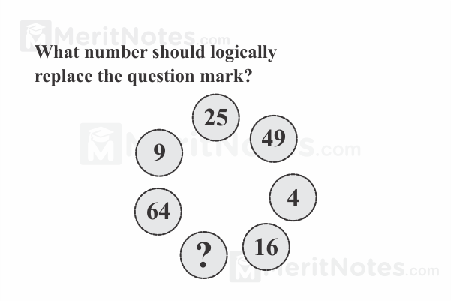

Answer: 36

Starting at 4 and moving three segments counter clockwise yields the sequence 4, 9, 16, 25, ?, 49, 64. These are perfect squares : 22, 32, 42, 52, 62,72.

**Q99:**

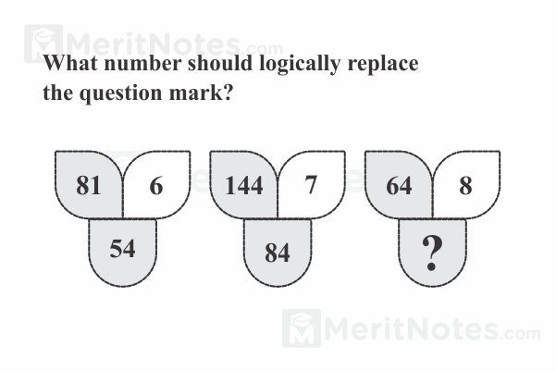

Answer: 64

The bottom number is the top right number times the square root of the top left number.

**Q100:  
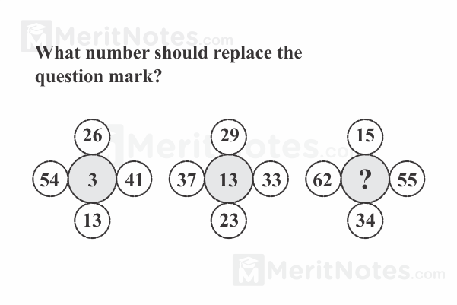**

Answer: 7

The center number is the sum of the top number and the bottom number divided by the difference between the left number and the right number. 7 = (15 + 34) Ã· (62 - 55).